

Disability Sunday

First Sunday in July

A day of focus on disability for churches and fellowships throughout the United Kingdom

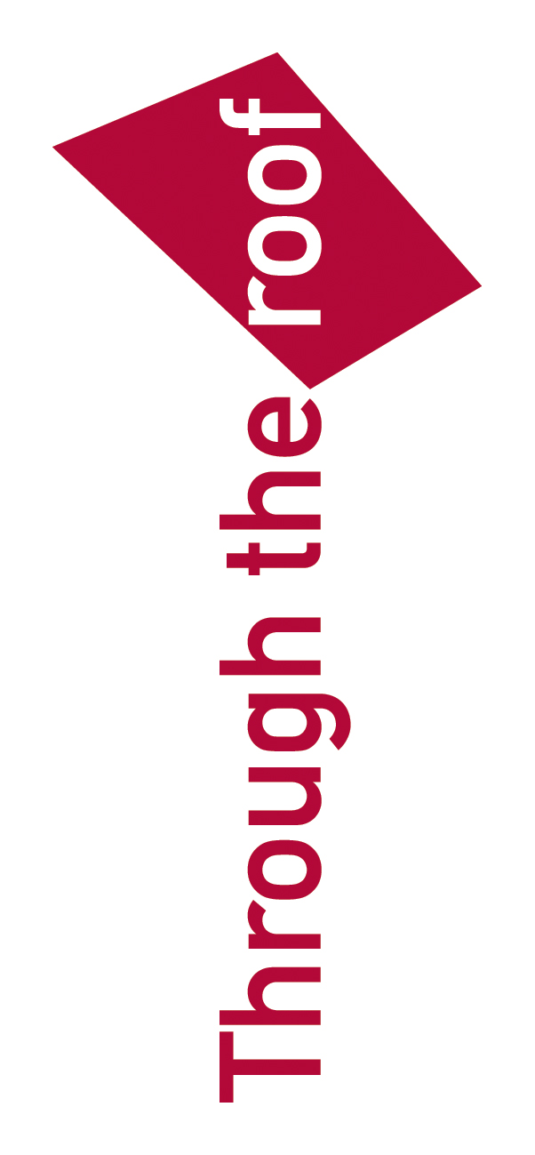

Created by

Through the Roof
www.throughtheroof.org

Contents

Introduction……………………………………………………………………………..3
Step 1 Form a team ……………………………………………………………………3
Step 2 Involve your Church's Leadership..…………………………………………..3
Step 3 Publicity…………………………………………………………………………3
Step 4 Develop your plan...……………………………………………………………4
Step 5 Welcomers and Stewards..……..……………………………………………..5
Step 6 Your Church Building………………………………………………………….5
Step 7 Church feedback questionnaire……………………………………………....5
Step 8 Transport……………………………………………………………………..….6
Sample letter of invitation………………………………………………….……….….6
Draft news release…………………………………………………….……………..….7
Church Newsletter Items……………………………………………………………..…8
Recruiting team members.….…………………………………………………………..8
Announcing the event. …………………..……………………………………………...8
Recruiting volunteers…………………………………………………..……………….8
Disability Sunday - Accessibility Checklist……………………………………………9
Guidelines for stewards and welcomers………………….………………………….10
A Drama for Disability Sunday “The Day the Floodgates of Heaven Opened”......11
Instructions for activities…………………………………………………..……………14
A quiz for Disability Sunday…………………………………………………………...15
Factsheets for factsheet activity……………………………………………………….17
Survey of Disability-Related Needs…………………………………………………...21
Notes for a selection of Disability Sunday Sermon options………………………...22
Suggested hymns for Disability Sunday……………………………………………...26
Introduction to children’s activity..................………………………………………….27
Children’s activity sheets……………………………………………………………….28
Children’s activity lesson plan…………………………………………………………30
More than just a day…………………………………………………………………….32
Further resources....................................................................................................33
What is Churches for All?........................................................................................34
Introduction
Disability Sunday is an annual event organised by Churches For All. Its purpose is to provide a day of focus on disability so that churches, both their leadership and their congregations, can reach out to the disabled members of their communities, and can begin to think and plan towards becoming a fully inclusive church where all members, disabled or otherwise, play their full part in the local expression of the Body of Christ. Thank you for choosing to take part in Disability Sunday 2014. We hope you will use the contents of this pack to plan your Disability Sunday service and that you will find its contents informative, encouraging and inspiring.

Step by Step

Step 1 Form a team
Find other people in your church who would be interested in helping your church participate in Disability Sunday. Ask disabled people in the church and others with experience of disability or a heart for disabled people. In addition to disabled people themselves, this may include parents of disabled children or medical or social service professionals.
Key points:
Share your vision with the team members.
Pray together for God's equipping for a Disability Sunday as well as future ministry.
Develop a proposal as to how your church would hold the Disability Sunday on 6 July 2014.

Step 2 Involve your Church's Leadership
If you are not part of the leadership of your church, you and your team should meet with your church's vicar, priest or pastor. (If your church does not have an individual leader, approach your church's leadership team). Present your team's vision for participating in Disability Sunday.
Key points:
Present why this reflects God's heart.
Express your team's willingness to take the lead in organising this.
Explain that the leaders' support and involvement are vital.

Step 3 Publicity
Disability Sunday is a wonderful opportunity to invite people who are disabled and their families from the community. Sample letters and posters are included in this document.
Publicity can be arranged through press releases to local newspapers and radio stations, letters to local residential, educational and day care facilities for disabled people, disability organisations, and local schools.
You should also publicise the event in your church starting early in May. Encourage the congregation to include family, friends or neighbours who are disabled.

Step 4 Develop your plan
Your team should choose which parts of the Disability Sunday programme you want to use. You must do the worship service portion in order for it to be successful. The other parts are strongly recommended because they reinforce the worship service and get people talking about the subject of disability.
Children's programme - Talk with the people responsible for your church's children's activities and review the programme with them. Make sure they make it their responsibility to carry out the children's programme. You will have other things to do and they will do a better job of it. Make sure you follow up with them on a regular basis to ensure that the children's leaders have what they need and are on schedule. You will need to make sure that there are extra helpers available to assist any disabled children who join the children's activities.
The Worship Service - There is no one order of service that suits all churches, so it will be up to you and your church leaders to put together the service. It is, however, important that particular care is taken to ensure that the welcome at the beginning draws attention to the facilities available for disabled people, e.g. that there is a loop system, where to sit to benefit from the loop, the provision of large print song sheets etc. The following items may form part of your order of service:
Someone with a disability to lead the service through
A quiz to test your knowledge about disability
A “Disability Facts” activity
Music by a disabled person or group.
Scripture reading and prayer by someone with a disability or a family member.
A sermon focusing on God's view of people with disabilities. A choice of two outline sermons is included in this document, including one based on the lectionary for the day, including opportunities for individuals in your congregation to contribute their own perspective.
A drama on the subject of disability
Involve disabled people at every level – taking up the offering, welcoming, giving out song sheets etc.
Be as creative as possible. However, a programme that is either not Christ-centred or that is completely different from a normal service will detract from future ministry.
How about donating your offering for 6 July to Through the Roof or another disability ministry that you already work with? We rely on donations for our work of making the Christian message accessible to all and we’d be very grateful if you’d consider making Through the Roof the beneficiary of the day.

Step 5 Welcomers and Stewards
Preparations for the day must include some training for the stewards or welcome team. A guidance sheet for stewards/welcomers is included in this document and can be copied and given out to the team. The training should take place before the day, but you should be in touch with the stewarding or welcome team leader well in advance. It is a good idea to have more welcomers and stewards than usual so that some can show visitors, both disabled and non-disabled people to their seats and introduce the guests to the person who will be sitting next to them.

Step 6 Your Church Building
Your church doesn't have to have perfect access for people with limited mobility, but it should not be an impossible challenge either. A basic checklist is enclosed for your church. Desirable for the Disability Sunday are:
Parking for people with disabilities (blue badge holders), which is monitored to make sure that they can park in a suitable place to access the service.
A way to get into the front of the building without steps.
Seating area for wheelchair users that is not only at the back. In other words you should be able to give people who use a wheelchair a choice of whether or not they want to sit in the back, middle or front.
Child care (crèche, Sunday School) which can meet the needs of a disabled child.
Large print programmes /orders of service, notice sheets and songs used on the overhead projector (if your church uses such items during a service). It is simpler to make all printed material for that day in large print: 16 point type sizes will meet most needs.
An induction loop for hearing aid users.
A British Sign Language interpreter for Deaf people.
Wheelchair accessible toilet facilities.
If you are following the Children's Programme, you should try and make sure those rooms are wheelchair accessible as well.

Step 7 Church feedback questionnaire
To plan for future disability ministry, collect feedback from the congregation on the service and ideas for meeting needs more effectively. A sample questionnaire is provided for your use. It can be copied and inserted in an order of service or notice sheet and collected after the worship service.
It is also useful for long term planning if you do a survey of the needs perceived by members of the congregation. This survey will let your team know what needs exist within your church and community. Again, a sample survey is provided for distribution widely within the church.

Step 8 Transport
You may need to consider how disabled people who do not have their own transport may be able to travel to your Disability Sunday service. Advice should be available from local disability charities or social services as to forms of transport which may be made available.
Finally,
A useful resource for improving your Church’s provision for disabled people is Through the Roof's Roofbreaker Guides, available to download from the website or to purchase for £5.00 excluding p+p.

Sample letter of invitation
(to be printed on church notepaper)

[date]

Dear

It’s a real pleasure to invite you and your friends, relations and colleagues, to attend a Disability Sunday event on 6 July 2014 at [11.00 am] at our church, which is in [Lupin Gardens, Ambridge]

The main talk will focus on what the Bible really says about disability and on God’s positive attitude towards disabled people. We have also asked a few members of our congregation to speak about their own experience of disability. We plan a drama and musical contributions by disabled people.

We would like to welcome anyone in our community who is affected by disability – you yourself or a member of your family may have a disability, or you may work with disabled people. We want the service to be a first step towards fully including disabled people in the life of our church. Our church building is accessible to wheelchair users and has an accessible toilet. An induction loop will be provided for hearing aid users.

If you have no transport and you need a lift, or if you have any questions, please call us on [phone number] as soon as possible and we will try to help.

With warmest good wishes

Draft news release

News Release

St Mark’s Church in Ambridge is holding a Disability Sunday service on 6 July 2014 at 11.00 am. There will be an exciting meeting of teaching and worship, led by disabled people, focusing on the world of disability.
Members of the congregation will be sharing their own experience of disability, there will be a drama and musical contributions by disabled people and there will be a brief talk on disability from a Biblical perspective.
The church is accessible to wheelchair users. A British Sign Language interpreter for Deaf people will be provided at the service. Child care is also available.
In addition to the worship service, disability awareness will be the special focus of the children's programme with groups for all ages.
For more information contact: Name:
Telephone:

************************************************************************************************
Print the news release with a church letterhead, and post it, email it or fax it to local radio stations and newspapers in early September.
Give details of any other special contributions to be made by disabled people. Avoid using Christian jargon words or phrases. If you want an expert eye to be cast over your News Release before you send it, email a draft to info@throughtheroof.org and we’ll be pleased to make constructive comments.
If your church is not manned continuously during office hours, make sure you give a mobile phone number as an alternative to the Church office. Nothing irritates media more than to be unable to get an immediate response to a question. Why not cultivate a relationship with your local reporter and invite them to come along?

Church Newsletter Items

Recruiting team members:

Many of you know the importance we attach to being fully inclusive of disabled people. We are planning to hold a Disability Sunday on 6 July 2014 with the following objectives:
- To show disabled people that God cares about them and their needs
- To raise awareness of disability and the needs of disabled people
- To give people affected by disability a voice
- To show that God responds to and uses disability in many different ways
- To show that including disabled people isn't a burden, but is a blessing and can be fun!
If you would like to serve on the planning team, please contact [name].

Announcing the event:

The Disability Sunday is just [number] weeks away. Just to remind you, what we want to achieve on the day is:
- To show disabled people that God cares about them and their needs
- To raise awareness of disability and the needs of disabled people
- To give people affected by disability a voice
- To show that God responds to and uses disability in many different ways
- To show that including disabled people isn't necessarily a burden, but is a blessing and can be fun!
Please invite friends, family and neighbours who are disabled or who are affected by disability on Sunday 6 July 2014

Recruiting volunteers:

Volunteers are needed to help with Disability Sunday. If you can help with [list needs here] then please contact [name]

Disability Sunday - Accessibility Checklist

Note: This is a very basic checklist to alert you to possible difficulties in the accessibility of your church building. It should be noted that a positive answer to all the points does not mean that your church complies with a generally accepted accessibility standard such as the Churches for All Bronze Standard or Part M of the Building Regulations. For more information, seek advice from Through the Roof.

Basic Accessibility |  |  | Yes | No
1. | Is it possible to get from a parked car to the area used for worship without going up or down a step or stairs?
2. | Is the slope of paths not greater than 5% (roughly 1:20)
Ramps
3 | Do ramps have a slope no greater than 1:12 and a width of no less than 1.2m?
4. | Do ramps have handrails on both sides?
Entrances and Exits
5 | Is at least one major entrance to the building usable by wheelchair users?
Doors and Doorways
6. |  | Do doors have a clear opening of 800mm or more?
7. |  | Can doors be opened easily by a wheelchair user or other disabled person?
Floors
8 |  | Is the floor level each side of doors?
9. |  | Are the door thresholds a maximum 13mm high?
Worship Space
10. |  | Can the service be heard clearly throughout?
11. |  | Is there an induction loop for hearing aid users?
12. |  | Is there good lighting, avoiding shadows on those speaking or interpreting?
13. |  | If an overhead projector is used, are there large print paper copies available for people who cannot see the screen?
14. |  | Is there space for wheelchair users where they can sit with a friend?
15. |  | Are there seats with arms and seats with extra legroom for people with mobility impairment?
16. |  | Can people take communion without climbing steps?
Toilets
17. |  | Is there an accessible toilet for use by wheelchair users?
Other areas
18. |  | Can disabled people access refreshments?

Guidelines for stewards and welcomers

DO | DON'T
General  Treat disabled people as you would anyone else.  Always speak directly to the person who has a disability.  Always ask the person who has a disability if you can help him or her in any way.  Whenever possible, seat disabled people with their friends or family.  Try to be aware of people's hidden disabilities such as epilepsy or Alzheimer's disease, which may require assistance.  Assume nothing - always ask! | Don't use negative terms such as "crippled" or "victim".  Do not consider a companion or carer to be a conversational go-between.
Visual Impairment  Identify yourself by name and as a steward.  Show a blind person to his or her seat.  Ensure they know large print songsheets are available.  Explain to a visually impaired person where things are located.  Provide space for a guide-dog to lie down by removing a chair. | Don't push a visually impaired person - always allow them to take your arm.
Deafness and hearing loss  Ensure your face and mouth can be seen clearly.  Look directly at the person and speak at normal speed with clear (not exaggerated) lip patterns. | Don't exaggerate or shout.  Don't speak directly into the person's ear.  Don't obscure your face
Speech Impairment  Give your whole, unhurried attention with good eye contact.  Remember the person with a speech impairment may use another method of communication, such as writing. | Don't finish a sentence or word for the person.  Don't get agitated or impatient
Mobility Impairment  Always ask a wheelchair user if she or he would like assistance before you help.  Try to sit or crouch down to talk to wheelchair users so that eye contact is easier.  Provide seats near the entrance for people with mobility difficulties to minimise walking. | Don't push a wheelchair user unless they ask you to.  Don't hold on to or lean on a person's wheelchair.
Learning Disabilities  Be patient, give someone with learning disabilities plenty of time. | Don't assume the person cannot understand you.

Sunday service Resources

Drama: The Day the Floodgates of Heaven Opened

Scene 1:
(4 people in ragged clothes sitting on the floor, scraping around on the ground in search of some weeds they might eat.)
Person 1: Even the weather is conspiring with the Arameans! At least we used to be able to find some plants to eat. Now with this drought there’s nothing.
Person 2: We might as well do away with ourselves now. The only choice we have is a quick death by our own hand or a slow death from starvation.
(Loud shouting is heard offstage of angry voices raised in argument. The shouting continues but not so loudly that the audience can’t hear the dialogue over it)
Person 3: What’s all that about?
Person 4: (Walks to one side of the stage to peer into the distance) By my life, has it come to that now?
Person 1: Come to what?
Person 4: Someone is selling a donkey’s head. They’re fighting over it, even though he wants £72 for it! It’s the first food they’ve had for days and some of the men are coming to blows over it.
Person 3: Great heavens, a donkey’s head! Is that what our people are reduced to now?
Person 2: You think that’s bad? That’s nothing to what I heard yesterday. They’ve resorted to eating the bodies of those who’ve died of starvation.
Person 3: I never thought I’d say this, but I think this is a good time to be an outcast. I could almost be grateful for the leprosy that leaves us shut outside the city wall.
Person 2: Why so?
Person 3: Well, the Aramean soldiers don’t harass us the way they harass the other citizens. And at least if we’re going to die of starvation we can do it in peace, away from all that hubbub.

Scene 2:
(A man is striding across the stage calling out in a loud voice. At one side the king is standing leaning on a soldier.)
Elisha: Listen, people, I’m bringing you the word of the Lord. Tomorrow about this you’ll be buying flour for 90 pence a kilo and barley for 45 pence a kilo in the gate of Samaria.
Soldier: Pull the other one! Even if God opens the floodgates of heaven this won’t happen!
Elisha: Mark my words, you’re going to see it with your own eyes, but you won’t get so much as a mouthful.
(Exeunt the king, soldier and Elisha. Enter the 4 outcasts)
Person 2: Well, we’ll starve if we stay here, and we’ll starve if we try and get into the city even if they let us in.
Person 1: (Examining the diseased skin on his arms) Which they won’t.
Person 2: So why don’t we go over to the Aramean camp and surrender?
Person 3: Are you mad?
Person 2: Well either they’ll kill us, which will be quicker than starving to death. Or else they’ll take us prisoner and there’s a chance they’ll feed us.
Person 4: You know what? I think you’ve got a point.
Person 1: Good thinking, come on, let’s go.

Scene 3:
Person 2: (Looking around everywhere) So who do we surrender to?
Person 1: Sshhh!
Person 2: What?
Person 1: Why is it so quiet? Where is everyone?
Person 3: I do believe all these tents are empty! Look – they’ve just dropped all their belongings, as if they left in a hurry.
(They begin walking all over the stage, looking at everything.)
Person 4: You’re right! The place is deserted.
Person 3: But why? Where is everyone?
Person 2: Something must have spooked them!
Person 1: Food!!!! Look! In every tent, they’ve all left their food behind!
(They start eating ravenously as if there was no tomorrow.)
Person 4: Hey guys, guys, wait a minute.
(They all stop eating and look at him.)
Person 4: This just isn’t right! Everyone in Samaria is starving and we’re sitting here gorging ourselves. We have to go and let them know. People are dying of starvation, we could be saving lives.
Person 3: he’s right, let’s go.
(Exeunt)

Scene 4
(The 4 men are seen hammering on the city gate.)
Gatekeeper: Go away! We’ve got enough trouble here, we don’t need your infection as well.
Person 1: Please listen to us! We’ve found food! Enough for everyone.
Person 3: The Aramean camp is deserted and it’s full of food, clothes, armour and treasure. The famine is over, we’re all saved!
Gatekeeper: Well come in then, you’d better tell this to the king.

Scene 5:
(The 4 men are standing on the stage along with the King and Elisha)
Elisha: Didn’t I tell you? Flour for 90 pence a kilo and barley for 45 pence a kilo. It was the word of the Lord and it came true.
King: Praise be to the Lord, the God of Abraham, who has heard our cry and saved us.
Elisha: Where is your guard who scoffed at my word, your majesty?
King: After we investigated to see if what these men said was true, and we found that the enemy had indeed fled, you can imagine that there was a stampede, everyone desperate to get to the food. And he fell and got trampled in the stampede, so truly all God’s word was fulfilled.
Elisha: You shouldn’t be surprised. He watches over His word, to perform it.
King: No, but you know what has really surprised me? That these 4 outcasts with their disease-ravaged bodies, should be God’s chosen instrument to save our nation. They were despised as good for nothing, but God has given them a great victory and they are honoured. I will not be so quick to judge by appearances in future.
– End –

At some point in your service you may wish to show the following video: https://www.youtube.com/watch?v=khaJz9Bvz38 You can also find more videos at https://www.youtube.com/user/throughtheroof/videos.

The following 2 pages contain a quiz to get your congregation thinking about disability and to test their knowledge about churches, disability and the law. We suggest that these quiz pages should be printed back to back so that they fit onto one sheet, and can be handed out with the order of service sheets by the welcome team. People can begin to fill these in while they wait for the service to start, but you may also want to allocate a small amount of time during the service for them to be completed. You might like to encourage people to swap their sheet with the person next to them and mark each other’s answers.

There is a PowerPoint with the answers to the quiz which can be downloaded from www.churchesforall.org.uk/disabilitysunday

On pages 17 – 20 there is a further activity which can form a part of your service. Each of these pages contains two disability factsheets. These need to be cut across the centre of the page to separate each one into two sheets. These sheets should be randomly distributed to the congregation. Each person should receive one sheet. Equal numbers of each of the 8 sheets should be distributed. You could do this either by the welcome team handing them out with the order of service and quiz sheets, or you could have one already placed on each seat. At some point in the service people should be invited to read what is on their sheet, and then find someone who has the corresponding sheet (it says on each sheet which corresponding sheet needs to be found). The two people should then read both sheets together and discuss what are the implications of these two facts when taken together.
Quiz for Disability Sunday

- The Equality Act, passed in 2010:
- Allows churches to choose how disability-friendly they wish to become.
- Requires churches to make provision for disabled people even if they currently have no disabled members or visitors.
- Only requires churches to make provision for disabled people if they already have one or more disabled members.

- A church that treats disabled people less favourably than its non-disabled members is:
- Probably not really in a position to improve things for disabled churchgoers.
- Shooting itself in the foot.
- Breaking the law.

- Under the Equality Act a disability is defined as:
- A physical or mental impairment that has a ‘substantial’ and ‘long-term’ negative effect on your ability to do normal daily activities.
- A physical or mental handicap that makes you less able to achieve than your peers.
- An illness or ailment that has a ‘substantial’ and ‘long-term’ negative effect on your ability to do normal daily activities.

- The Equality Act requires churches to make reasonable adjustments to their physical premises to meet the requirements of disabled people. This means:
- A voluntary body such as a church is not expected to make structural alterations.
- Adaptations such as ramps and toilets that are not structurally impossible or prohibitively expensive have to be made.
- If a listed church building cannot be adapted to make a disabled toilet, it will have to be de-listed and alterations made.

- The best way to describe someone in a wheelchair is:
- Wheelchair bound.
- Wheelchair user.
- Confined to a wheelchair.

- Your church needs to hire a portable ramp to get a wheelchair user up 2 steps into the church hall for the Christmas party. The law provides for you to:
  - Exclude the wheelchair user from the party.
  - Charge the wheelchair user extra for their ticket to cover the hire of the ramp.
  - Enable the wheelchair user to attend the party at the church’s expense.

- Out of all disabled people, the percentage who use wheelchairs is:
  - 8%
  - 23%
  - 58%

- In a church, the people who should ideally be given disability awareness training are:
  - Only the minister.
  - All elders, leaders, church staff and volunteers such as stewards and Sunday school teachers.
  - Members who have an interest in helping disabled people.

- The best churches:
  - Don’t necessarily comply with the letter of the law on disability, but try to be friendly and welcoming.
  - Study the Equality Act and ensure that they comply with all of its requirements.
  - Implement the Equality Act in full, but go beyond that to look at how they can enhance the relationships so that disabled and non-disabled people in the church become fully interdependent.

- A disabled person visits your church for the first time, and you want to make them welcome. It’s best to:
  - Not mention their disability – you don’t want to embarrass them.
  - Don’t assume anything – ask them how you can help them get the most out of their visit to your church.
  - Use your judgement to make the best guess at what assistance or provision they might need.




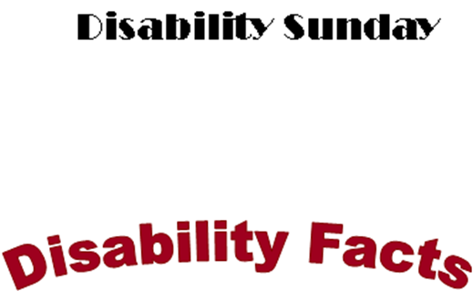


On 17th May 1999 The Times reported the findings of a study about disabled people at work. The study found that disabled employees are more loyal, harder working, take less sick leave, and are up to 110% more productive than their non-disabled colleagues.

Does that surprise you?

Now find someone who Fact No. 2.

Putting these 2 facts together, what does it tell you about the world of work?

Statistics compiled by the Civil Service Trades Unions show that disabled civil servants are much less likely to be given pay rises for good performance than their non-disabled colleagues

Does that surprise you?

Now find someone who has Fact No. 1.

Putting these 2 facts together, what does it tell you about the world of work?



Disability is very expensive. Even in the UK where benefits and local authority funding are more generous than in many parts of the world, a substantial amount is needed to cover the shortfall for aids such as a wheelchair adapted car, stair lift, magnifying computer screen and extra large keyboard for visually impaired people, textphone for Deaf people, etc.

Does that surprise you?

Now find someone who has Fact No. 4.

Putting these 2 facts together, what does it tell you about the relationship between disability and poverty?

Worldwide, disabled people are in the poorest 2% of the population. They are the most likely to be unemployed and the least likely to have qualifications that would enable them to get a job. Often they are not incapable of work but employers don’t recognise their potential or consider them for jobs.

Does that surprise you?

Now find someone who has Fact No. 3.

Putting these 2 facts together, what does it tell you about the relationship between disability and poverty?



Disabled children often have extra requirements to help them access education. Some need learning support because of their learning difficulties. Others might need a scribe to write for them, a laptop computer to work on or a dictating machine to make notes in lessons.

Does that surprise you?

Now find someone who has Fact No. 6.

Putting these 2 facts together, what does it tell you about the relationship between disability and the illiteracy/poverty cycle?
In developing countries 98% of all disabled children not only have no learning support, they actually receive no education at all. Their disabilities make it difficult to secure employment, but this is compounded by their lack of any literacy and numeracy skills, leading many employers to see them as unemployable.

Does that surprise you?

Now find someone who has Fact No. 5.

Putting these 2 facts together, what does it tell you about the relationship between disability and the illiteracy/poverty cycle?

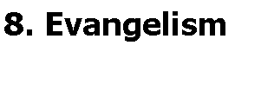
“Every person in every nation in each succeeding generation has the right to hear the news that Christ can save...”© So says an old chorus that used to be popular in missionary circles. That is as true of disabled people as it is of the rest of us. Disabled people need to be presented with the Gospel in a format that they can understand and apply to themselves. Like everyone else they need to know how much God loves them. The church has to model the love of God to the world, or no one will believe in it.

Now find someone who has Fact No. 8.

Putting these 2 facts together, what does it tell you about how well the church is fulfilling its God-given mission?
© Jim Webb, Grace Publications. By kind permission
In 2004 the Lausanne Committee for World Evangelism reported that “Only 5 to 10% of the world’s disabled are effectively reached with the gospel, making the disability community one of the largest unreached…. or hidden people groups in the world. Jesus, aware that this population would be overlooked, made people with disabilities a target group of the Great Commission (Luke 14:12-24).” In other words, between 90% and 95% of disabled people worldwide never get to hear the Gospel.

Now find someone who has Fact No. 7.

Putting these 2 facts together, what does it tell you about how well the church is fulfilling its God-given mission?
Survey of Disability-Related Needs

1. Is a member of your family disabled?  Yes  No

2. Do you have a friend or neighbour who is disabled?  Yes  No

3. How does their disability affect them?

______________________________________________________________

______________________________________________________________

4. Does he/she attend church regularly?  Yes  No

5. If not, would he or she like to?  Yes  No

6. Does your friend or family member have any particular needs the church might be able to meet?

7. If your friend or family member would like to attend this church, what changes, if any, should we make?

❑ Parking
❑ Accessibility (please specify) ____________________________________
❑ Induction loop
❑ BSL interpreter
❑ Large print material: songsheets, notice sheets, Bibles______________
❑ Better lighting
❑ Wheelchair space which does not obstruct aisles
❑ Special provision for an adult or child with learning disabilities
❑ One to one support for a child in Sunday School

Please provide contact details so that we can talk to you some more about meeting some of these needs:

Name ____________________________ Telephone number __________________

Address ____________________________________________________________

___________________________________________________________________

Any other comments __________________________________________________

___________________________________________________________________

Notes for Disability Sunday Sermon (1)
Aim: to help a congregation to see why they should be motivated to be fully inclusive of everyone, including disabled people.

Bible reading: Mark 10. 46 – 52. Consider reading this from the Easy-to-Read Version, for the benefit of Deaf and learning-disabled people:

⁴⁶ Then they came to the town of Jericho. When Jesus left there with his followers, a large crowd was with them. A blind man named Bartimaeus (meaning “son of Timaeus”) was sitting by the road. He was always begging for money. ⁴⁷ He heard that Jesus from Nazareth was walking by. So he began shouting, “Jesus, Son of David, please help me!”
⁴⁸ Many people criticized the blind man and told him to be quiet. But he shouted more and more, “Son of David, please help me!”
⁴⁹ Jesus stopped and said, “Tell him to come here.”
So they called the blind man and said, “You can be happy now. Stand up! Jesus is calling you.” ⁵⁰ The blind man stood up quickly. He left his coat there and went to Jesus.
⁵¹ Jesus asked the man, “What do you want me to do for you?”
He answered, “Teacher, I want to see again.”
⁵² Jesus said, “Go. You are healed because you believed.” Immediately the man was able to see again. He followed Jesus down the road.

Title: “You are Christ’s body”

Few concepts have, perhaps, been more misunderstood than the idea of the Church as the body of Christ. From casual attitudes to the sacrament of communion, to the naming of a warship “Corpus Christi”, it seems that little real thought has been given to what this means in practice.
Yet it’s not really so very complicated. Everything that Christ’s physical body did when He walked on this earth, we as His body are to do now. Christ’s body walked many miles to find the people His Father wanted Him to engage with. Christ’s body sacrificed sleep to rise early and spend much time in communion with His Father God. Christ’s body never spoke an unkind word, though some of His truths were hard to swallow. Christ’s body never made anyone feel excluded, marginalised, undervalued or unimportant. Christ’s body ultimately suffered and died to rescue the race of humanity that He loved so much.
Christ’s body never cared about anyone’s opinion of Him except God’s. Christ’s body sat and received a service from someone no other rabbi would have allowed near him - a woman. Christ’s body singled out the marginalised, the outcasts, those whom society deemed a burden, and gave them His full attention. Christ’s body watched sorrowfully as a rich young man turned down the offer of his place in God’s kingdom, and then cheerfully moved on and offered that place to those who would not hold it so lightly – the poorest members of his community, those with diseases and disabilities, those whom the community rejected for their occupation such as tax collectors and prostitutes.
And we are His body. Yet do we mirror the things His physical body did here on earth? He Himself said, “It is enough for the servant to be like His master.” If we truly claim to be following in His footsteps, one place we can begin is by offering the same acceptance to people with disabilities that He offered – welcoming them, serving their needs, ensuring that the physical environment in our churches and homes doesn’t make access impossible for them, discerning their gifting and allowing them to use it to build up Christ’s body, knowing that without them we are incomplete and lacking in some of the graces that God has for us.
The church has been guilty of overlooking people with disabilities in the past, and has been the poorer for it. Let’s examine every aspect of our church life and ensure that no one is excluded from fulfilling their God-given role in His kingdom. Only in this way can we attain the measure of the fulness of the stature of Christ.
In the Bible reading, Jesus stopped what He was doing and gave His full attention to the blind beggar who was calling out to Him. When the man was brought to Jesus and it became apparent that he was blind, no doubt everyone expected Jesus to heal Him at once. After all, Bartimaeus’ need was for sight, and Jesus was the healer. But Jesus Himself made no such assumptions. Instead He allowed Bartimaeus to articulate what he saw as his need by asking, “What do you want Me to do for you?”

For this next section the preacher will have briefed several people a few weeks in advance, to give them time to prepare their answers. Suggested types of people include a newly divorced person; a widow(er), a disabled person, a parent of a disabled child, a recent immigrant. He/she will then explain to the congregation that each of these people has been asked to imagine that Jesus is physically present and is asking them the question He asked Bartimaeus: “What do you want Me to do for you?” Each of them should then come and explain what they would ask Jesus to do for them if He were physically present.

Preacher:
If Christ were physically present today, He would ensure that these needs were met. We have heard today that…. (examples: parents of disabled child want babysitters so they can have regular date nights / widower wants to be invited to Sunday lunch / divorced woman is struggling to make ends meet and gifts of food would be very welcome / disabled person wants relationships that go beyond Sunday morning and become real mutual friendships / recent immigrant wants someone to befriend and teach her English, etc.)
If Christ were present in bodily form, He would make whatever effort and sacrifice it took to meet these needs. But Christ IS bodily present. We are the body of Christ. Christ’s body would…. (give up an evening to babysit, go to the supermarket and buy a basket of shopping, cook Sunday lunch and invite [widower], spend time developing a friendship with [disabled person], spend time with [recent immigrant] helping them to learn English language and customs). But WE are able to do these things, and if we don’t do them, we have no right to call ourselves the body of Christ.
So I’m going to invite you to do two things. Firstly, if you have a need which is not being met, please let us know your answer to the question, if Jesus were physically here, what would you be asking Him to do for you? And secondly, please consider which of the needs you’ve heard today you can commit to meeting, or helping to meet.
But with one word of caution. It’s worse to have some help dangled before you which then doesn’t materialise than to receive no offers of help. So please only offer help that you know you can commit to, and go on keeping it up for the long haul even after today’s sermon is only a distant memory. It is what Christ’s body would do if He were physically here.

Notes for Disability Sunday Sermon (2)
Note for Anglican churches: This sermon outline is based on today’s Gospel reading from the lectionary. The Easy to Read Version of the Bible is used throughout.

Matthew 11.16 – 19, 26 – 30 Easy to Read Version
“What can I say about the people who live today? What are they like? The people today are like children sitting in the marketplace. One group of children calls to the other group, ‘We played flute music for you, but you did not dance; we sang a funeral song, but you were not sad.’ Why do I say people are like that? Because John came, not eating like other people or drinking wine, and people say, ‘He has a demon inside him.’ The Son of Man came eating and drinking, and people say, ‘Look at him! He eats too much and drinks too much wine. He’s a friend of tax collectors and other sinners.’ But wisdom is shown to be right by what it does…”
Then Jesus said, “I praise you, Father, Lord of heaven and earth. I am thankful that you have hidden these things from those who are so wise and so smart. But you have shown them to people who are like little children. Yes, Father, you did this because it’s what you really wanted to do. “My Father has given me everything. No one knows the Son—only the Father knows the Son. And no one knows the Father—only the Son knows the Father. And the only people who will know about the Father are those the Son chooses to tell. “Come to me all of you who are tired from the heavy burden you have been forced to carry. I will give you rest. Accept my teaching. Learn from me. I am gentle and humble in spirit. And you will be able to get some rest. Yes, the teaching that I ask you to accept is easy. The load I give you to carry is light.”

In the first part of today’s reading, Jesus is describing a group of people who have never learned the secret of contentment. No matter what life held, they were not content. And, like all discontented people, they were fault-finders. Whether it was John’s life of frugality or Jesus’ liberal abundance, all they had for them was criticism.
Contrast this with St Paul, who suffered much – some of it voluntarily for the sake of the Gospel, and some of it involuntarily. He described a “thorn in the flesh” which caused him much trouble. He didn’t specify what it was but we do know from contemporary descriptions of him and from his letter to the church in Galatia that he had a serious eye problem. And yet he could write, “I have learned to be satisfied with what I have and with whatever happens. I know how to live when I am poor and when I have plenty. I have learned the secret of how to live through any kind of situation—when I have enough to eat or when I am hungry, when I have everything I need or when I have nothing.”
Or contrast it with Fanny Crosby who wrote many of the hymns we love, including “Blessed Assurance” and “I shall see Him face to face.” She was blind all her life, and yet she could say, “It seemed intended by the blessed providence of God that I should be blind all my life, and I thank him for the dispensation. If perfect earthly sight were offered me tomorrow I would not accept it. I might not have sung hymns to the praise of God if I had been distracted by the beautiful and interesting things about me… When I get to heaven, the first face that shall ever gladden my sight will be that of my Saviour".
The middle section of the Gospel reading shows Jesus affirming that it’s not by human wisdom that we discover God’s secret of contentment. It’s not the intelligent and powerful who discover it, but God reveals it to the simple and childlike. This is why someone with a learning disability who struggles to understand our confusing social rules and perhaps lacks the skills to learn to read may have a deeper understanding of and relationship with God than those of us who use our minds more than our hearts to interpret the world. This again ties in with some words of St Paul in 1 Corinthians: “Brothers and sisters, God chose you to be his. Think about that! Not many of you were wise in the way the world judges wisdom. Not many of you had great influence, and not many of you came from important families. But God chose the foolish things of the world to shame the wise. He chose the weak things of the world to shame the strong. And God chose what the world thinks is not important—what the world hates and thinks is nothing. He chose these to destroy what the world thinks is important.”
And finally, after affirming that He is the only way through which we can come to know the Father, Jesus reveals the secret of contentment that had escaped the people He was referring to. Contentment comes through laying down our heavy burdens and coming to Him for rest. Jesus had grown up working in a carpenter’s workshop. He would probably often have been asked to make a yoke to harness oxen together to pull the plough. He would have understood the importance of making a good quality, well-fitting and comfortable yoke. An ill-fitting yoke would chafe and cause sores to develop on the oxen.
Jesus could see that the discontentment all around him was like an ill-fitting yoke. People were putting on themselves something that chafed and made their lives irksome and unpleasant. He was inviting them, as He invites us, to put off that yoke and come to Him, to yoke themselves to Him with a yoke that will not chafe, a yoke that comes from imitating his humility and lowliness of spirit. We will find in laying down the heavy things we’ve put on ourselves – the questions that torment us, the envy of those around us and the impossibly high standards we set ourselves but cannot live up to, that the burden He lays on us is as light as a feather. The secret of it lies in the first three words of this section: Come to Me. We can observe Jesus and try to imitate Him, and eventually it will become just another burden that weighs us down. But if we come to Him, draw near to Him and live our lives out of that daily closeness, we will find that we are like a young ox wearing a comfortable yoke which holds him close to an older and more experienced ox. We will fall into the same natural rhythm as His as we walk through our daily lives, and self-effort will cease as He produces His life in us. This is the secret of true contentment.
I now want us to listen to some people who have experienced perhaps more adversity and difficulty in life than many of us, and yet have discovered a contentment that comes from the presence of God in our lives.
At this point, the minister will have briefed several members of the congregation in advance to come and give a short testimony. Suggested types of people include a newly divorced person; a widow(er), a disabled person, a parent of a disabled child, a recent immigrant. Their testimonies will focus on ways in which their relationship with Christ has carried them through the difficulties that life has presented to them.

Disability Sunday hymns

Below is a list of suggested suitable hymns for Disability Sunday arranged by categories (in a variety of different styles for different worship traditions). This is not a rigid prescription – you may be able to think of some better ones not on the list – but is intended to help you as you seek to craft a worship service around the topic of disability. Where applicable we have included copyright information.

We would like to suggest that you choose one of your hymns and deliberately omit the words from the service sheet, overhead projector or whatever you use. By depriving people of the written words of one of the hymns, you will be asking them to sing from memory, and in so doing to share in the regular Sunday experience of blind church members.

Hymns about our unity and equality in Jesus Christ
All heaven declares
I’m accepted
In Christ there is no east or west
Let there be love
The earth is the Lord’s
In my life, Lord , be glorified
Jesus, stand among us
The King is among us
For I’m building a people of power
The Church’s one foundation
Take my life and let it be

Hymns about God’s faithfulness and our dependence on Him
Because he lives
Ten thousand reasons
Great is Thy faithfulness
Father, hear the prayer we offer
Blessed be your name
Father, I place into your hands
What a faithful God have I
Lord I come to You (the power of Your love)
Consider it joy (though trials may come)

Hymns about God’s justice, and our call to reflect Him
Hail to the Lord's anointed
Filled with compassion
Lord, speak to me that I may speak
Do Something Beautiful
God of the poor (beauty for brokenness)
Christ for the world we sing
I see the King of glory
See your Saviour comes
The Spirit of the Lord is on me now

Hymns about God’s healing power in our lives
I'll praise my Maker
Jesus the name high over all
At even ere the sun was set
O for a thousand tongues to sing
There is none like You
Greater grace, deeper mercy
Broken hearts
Thank you for the cross (O I love You Lord)

Hymns about our mutual interdependence in Jesus Christ
A new commandment
Bind us together
Jesus put this song into our hearts
Lord, make me an instrument
Make me a channel of your peace
The Servant Song (Brother, sister, let me serve you )
Blest be the tie that binds
So great (Young and old, rich and poor)
For I’m building a people of power
Blest be the dear uniting love
How good and how pleasant
Here for good (we are the church)

Children's Activities age 5-11

The information sheets for the children’s activity follow on the next two pages. There are two to a page; you will need to cut across the centre of the page to separate each pair of information sheets.
In guiding the discussion it is best to encourage the children to think from the viewpoint of the disabled child – a child who has much the same likes, dislikes, dreams and feelings as everyone else in the group, who has a right to autonomy, independence and choices to exactly the same extent as any other child of the same age. So this is not a matter of “extra help” for an “unfortunate” child, but of presenting equal opportunities to the diverse range of children.
A full lesson plan, which can be adapted for different lengths of session, and different ages and abilities of children, follows the information sheets. One way of using the information sheets is suggested in the lesson plan. However, this also can be adapted according to the age and ability of the children. Older children may like to answer the questions individually first. Very young children will probably get most out of it if it is done as a whole-group activity, led from the front.
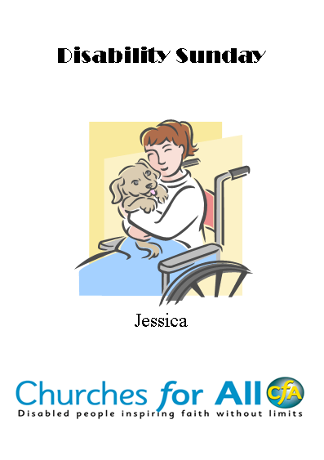
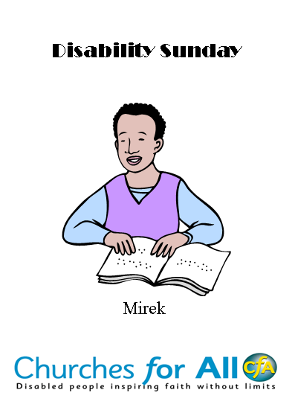
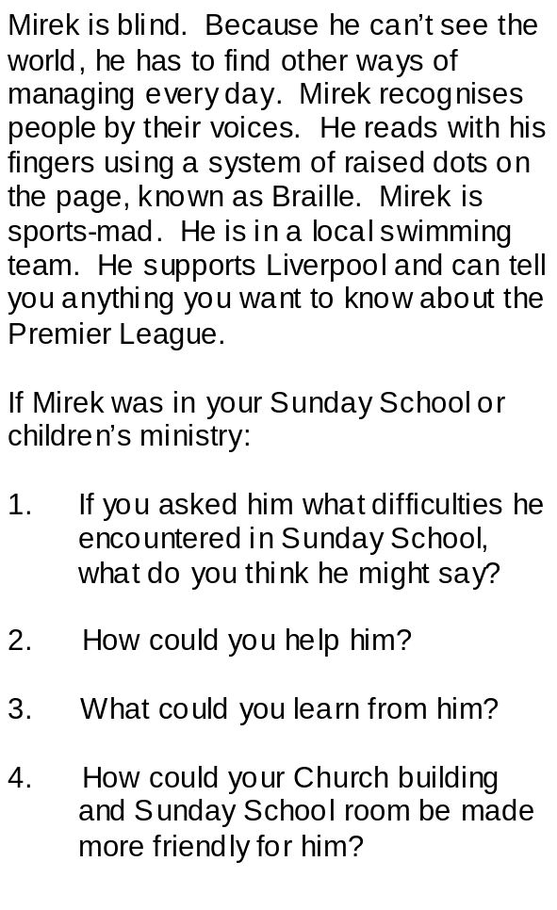
Jessica uses a wheelchair. She cannot stand up or walk by herself. Jessica is good at reading and art and she loves animals.
If Jessica was in your Sunday School or children’s ministry:
- If you asked her what difficulties she encountered in Sunday School, what do you think she might say?

2. How could you help her?

3. What could you learn from her?

4. How could your Church building and Sunday School room be made more friendly for her?

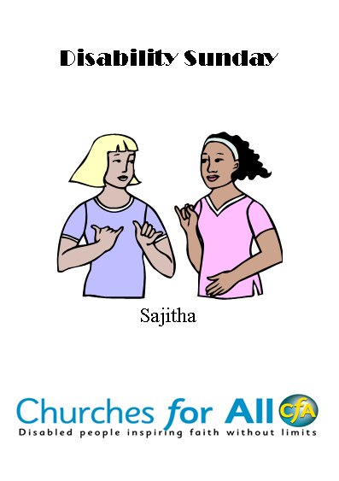
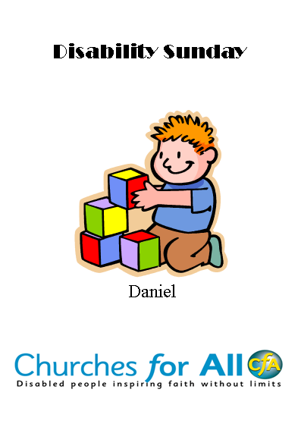
Sajitha is Deaf. Her mum and dad are Deaf too. Her parents speak British Sign language, so Sajitha learned British Sign Language before she learned English. She is quite good at understanding people by watching their lips (called lip-reading) but to make sure she understands what is being said she needs an interpreter who can translate everything into sign language for her. Sajitha loves Geography and History and does very well at school. She is also very good at art.

If Sajitha was in your Sunday School or children’s ministry:

If you asked her what difficulties she encountered in Sunday School, what do you think she might say?

2. How could you help her?

3. What could you learn from her?

4. How could your Church building and Sunday School room be made more friendly for her?

Daniel has autism. This makes it hard for him to get to know other people, although he really wants to be friends. He doesn’t always understand what he’s allowed to do and why, and sometimes if there’s a lot of noise or bright colours it makes him panicky, and he can take a long time to calm down again. Daniel is very good at understanding how things work, such as car engines, and he’s a good singer.

If Daniel was in your Sunday School or children’s ministry:

If you asked him what difficulties he encountered in Sunday School, what do you think he might say?

2. How could you help him?

3. What could you learn from him?

4. How could your Church building and Sunday School room be made more friendly for him?

Children’s activity lesson plan

As the children enter they should be handed the activity sheets. Take register, sit them down and explain that today is Disability Sunday, and that as a church we are thinking about what we can do to make sure that disabled people are as much a part of the church as non-disabled people.(5 minutes)

Ask the children to hold up their information sheet so everyone can see the picture side. Tell them to get into a group with the people who have the same sheet. In their groups they should try to answer the 4 questions on the back. (10 minutes)

Each group should appoint 1 person to feed their answers back to the rest of the class. Ask the class who is the best person to tell you what a disabled child would need to participate fully in your Sunday School? Answer: the child and his/her parents. (5 minutes)

Choose one or both of the following activities, depending on the age and ability of the class, and the length of time available.

Activity 1:
Materials needed: Copy of the book “Parachute Bible Stories”, 1 play parachute, paper and coloured pencils.
Using “Parachute Bible Stories” enact the story of The Big Feast from page 22. Then ask the children to draw a picture or create a story-board of the story. (25 minutes)

Activity 2:
Materials needed: Paper or card, scissors, glue, coloured pencils, decorations to stick to the card.
Ask the children, if they could invite anyone they wish to a party, who would they ask? (Answers might include David Beckham, One Direction, current X Factor entrants, etc., etc.) Get them to design an invitation to invite this person/people to a party. Read Luke 14.12-24 to the children. Discuss with them who might be the modern equivalent of the people Jesus is referring to (homeless people, disabled people, people who live alone, people newly moved to this country who have left their families behind, etc.) Now design an invitation for one of these people to come to a party. (25 minutes)

What have we learned?
Who does Jesus say are the most important people at the party? Who does Jesus say will reward you if you invite people who can’t repay you?

Conclusion
Conclude with a prayer time, in groups, encouraging the children to pray about what they have learnt and for those they know who are disabled.
Finish with this prayer, or one of your own: Dear heavenly Father, you don’t see any difference between us just because of our physical or learning abilities. You love us all the same, because we are all Your children, made in Your image. Please help us to be aware of the disabled people in our community. May we all, disabled and non-disabled, feel welcomed, included and befriended, and may we all have the opportunity to use our talents and abilities to help others. Amen.

More than just a day

We’re sure you will find that your Disability Sunday opens new doors for your church and inspires people to reflect God’s heart for disabled people all the more; you won't want to limit yourself to just one Disability Sunday.

Here are four things you can do

1. PRAY
Ask God for opportunities to use the gifts and talents He has given you to make a real difference in the lives of disabled people.

2. BECOME A DISABILITY CHAMPION
- You could encourage your church to sign up to, and take on board the
Churches Inc Charter initiated by Livability and Through the Roof.
- Find out about opportunities to volunteer and support the work of disability
charities in your area.
- Take practical steps to make disabled people feel welcome and included in
every area of church life by developing your own disability ministry.
- There are further resources and training you can obtain from various Christian
disability organisations, to help you develop your ministry. Details are given at
the end of this document.

3. GIVE
There are many simple, practical things we can do to raise money for various disability charities such as organising a collection, sponsored activities, selling Christmas cards, carol singing or holding a special service.

4. KEEP DOING IT
Make Disability Sunday an annual event and broaden the theme to include a variety of ways in which God works through pain, suffering and brokenness.

Further specialist resources
(Please obtain from the individual organisations at the contact addresses given at the end of this pack.)

Through the Roof
Hearts in Motion – a six-lesson Bible study exploring disability from a biblical perspective
Roofbreaker Guide – simple and practical advice on how to make your church welcoming to disabled people
Come In – making your church buildings accessible to disabled people
Guidelines for stewards/welcomers - double-sided, playing card-sized, laminated cards that give the key principles of inclusion in bullet-point format
When God Weeps by Joni Eareckson Tada - a book on pain and suffering
Depressed or Possessed by Joe Hayes – a book recognising and responding to mental illness
Bible Teaser postcards come with instructions on how you can throw a pizza -pudding-postcard-people party to get your church or house group thinking and planning how to include and welcome disabled people. There are two packs available, at £5 each or £7.50 for both packs purchased together. Here is the link: http://www.throughtheroof.org/shop/product_info.php?products_id=80&osCsid=6f870526fbc085986e73122cdff8a4c5

Disability Factsheets introduce you to a range of issues including education, housing, leisure and crime in the context of disability and include suggestions as to how your church can make a difference to the lives of disabled people in your family in respect of each of these issues. These can be downloaded from www.throughtheroof.org.

Enabling Church by Dr Gordon Temple with Lin Ball, 112-page paperback (by SPCK). The flexible material in the book is presented in seven sessions ideal for small groups, with Bible study discussion questions, activities, prayer and worship suggestions, and real-life interviews with disabled people.

Prospects
Worship CDs and other resources, - featuring original songs with simple lyrics.
Makaton materials and Makaton signing
Remembering God’s Love - understanding the service of Holy Communion
Easy to understand Bible Reading Notes, - available both in written and audio (CD) format, to help people with learning disabilities grow individually in faith
A member of our mission development team will be happy to visit and talk to you about training, resource materials and the affiliation partnership programme.

Livability
Life to the full – 10 things your church can do to involve disabled people - free
resource
The Community Mission Team - can run training courses and retreats to motivate
congregations to become active in outreach and social involvement

Torch Trust
FourSight – a booklet about including blind and partially sighted people in the life of the church, available in print, giant print and Braille

Enabling Church by Dr Gordon Temple with Lin Ball, 112-page paperback (by SPCK), available in braille, large print and audio editions from Torch Trust. The flexible material in the book is presented in seven sessions ideal for small groups, with Bible study discussion questions, activities, prayer and worship suggestions, and real-life interviews with disabled people.

Go Sign!
Sign Me In! - a policy for including deaf people in the life of the church
Christian Signs - booklet and DVD on British Sign Language resources, which includes people giving their testimony in sign language, as well as a video clips of Christian vocabulary translated into BSL (also available online at www.christiansigns.co.uk)

ASNA
Making the Gospel accessible - a practical training guide and resource manual for Special Needs Co-ordinators within the British Union of the Seventh-day Adventist Church. (Applicable to all churches).

Mind and Soul
UK Directory of Christian Counselling and Care - compiled by the Association of Christian Counsellors for Premier Lifeline, this is an invaluable resource for finding trusted and reliable Christian counselling and care across the UK

Open Ears
Advice about inclusion of hard of hearing and deafened people in church life - contact Open Ears on 01425 615215 or admin@openears.org.uk
Other
Guidelines for producing print material suitable for people with all levels of sight are available in the "See it Right" book and CD-Rom produced by the RNIB. Contact the RNIB on 0845 702 3153 or see their website: www.rnib.org
Information about website accessibility is available on the RNIB website. The Web Access Centre is located under "Good Design".
Equal Sign is a translation service from English text to British Sign Language (BSL) on video. www.equalsign.co.uk
Signs of God offer advice about booking and using BSL (British Sign Language) interpreters - see their website: www.signsofgod.org.uk

What is Churches for All?
Churches for All is a partnership of UK Christian disability organisations.
The Churches for All partners have a breadth of experience and depth of knowledge
on disability issues - challenging and enabling churches to fully include disabled
people.

Our aim is to help churches create and sustain an environment where disabled people can participate fully in church life for the benefit of all. Disabled people are involved in the leadership of Churches for All and many of its partner organisations.
Together, we strive to equip churches to reach towards their full potential by truly
including and involving disabled people.

The Churches for All Partners

A full life in Christ for people with learning disabilities. 0118 951 6978


Christian literature and fellowship for blind and partially sighted people.
01858 438 260


Supporting and enabling deaf Christians through networking, equipping, teaching and outreach.
01702 613 114


The new name of Grooms-Shaftesbury. Provider of care, housing, education and holidays for disabled people.
020 7452 2000


Transforming lives through disabled people..
01372 749955


Fellowship for non-signing hard of hearing Christians
01425 615 215.


Exploring Christianity and mental health.


To support the spiritual, social, emotional and physical needs of people living with special needs and disabilities.
01491 833395

